


MyWorkSpace 2.2
User Guide

Research & Development Unit
Open Source Competency Center (OSCC),
MAMPU,
Lot E302-34, Enterprise Building 3,
63000 Cyberjaya, Selangor
Tel: 03-83191200
Fax: 03-83193206

Table of Contents
Introduction 1
Internet Messaging Protocol (IMP) 2
Login to IMP 3
Setting Up Options 5
Change Color Scheme 5
Handling E-mail 7
How to Manage Messages 7
Sorting Messages in the Folder 8
Message Flags 8
Checking for New E-mail 9
Reading Messages 9
Sending and Composing Messages 11
Saving Drafts messages and Outgoing Messages 11
Replying and forwarding Messages 12
Sending Attachments 12
Spell Checking 13
Deleting and Moving Message 13
Selecting and Marketing Messages 14
Moving or Copying Messages 15
Managing Mail Folders 15
Auto-Reply (Vacation) 16
Auto-forrward 16
Address Book 17
Setting Up Address Book 18
Calendar 21
Create and Share Calendar 22
To add an event 24
Notes 25
To view Notes 25
Add New Note 25
Search Note 26
Creating and Sharing Notepad 26
Task List 27
Change Password 28

Introduction
MyWorkSpace is a collaboration suite which provide calendar, address book, notes and task todo. MyWorkSpace consists of this following components:
- Web User Interface
- Mail Server component
- Virus Scanning component
- SPAM Filtering component
- Users Administration component

Features:
- Public and shared resources
- Integrated user management, group support and permission system with the tools from third party
- Synchronization with PDAs, mobile phones and groupware client
- Message filtering and searching
- Spell checking
- Quota support

Internet Messaging Protocol (IMP)
Internet Messaging Protocol (IMP) is a web-based (webmail) clients written in PHP. It is a intermediary between user's web browser and the mail server.

Features:
- Provide IMAP and POP3 webmail client
- Message filtering and searching
- HTML message composition with WYSIWIG editor
- Spell checking
- Built in attachment viewers
- Encrypting and signing of messages (S/MIME and PGP)
- Quota support

Advanced Features:
- Keyboard navigation
- Full character set support for folders names and email messages
- Conversation view of all messages in a thread Folder tree in left menu pane
- Message previews in mailbox view
- Downloading of message attachments in a ZIP file
- Fetching of messages from external email accounts
- Flexible, individual alias addresses IMAP folder subscriptions Shared IMAP folders
- Graphical emoticons Support for mailing list headers
- Forwarding of multiple messages at once Attachments sent as links

Login to IMP
To login to the webmail, open mail url. It will prompt for username and password. Then click on the Login button. Example as below:
Mail URL: http://test.domain/webmail
Username: demo1
Password: demo123 (encrypted)
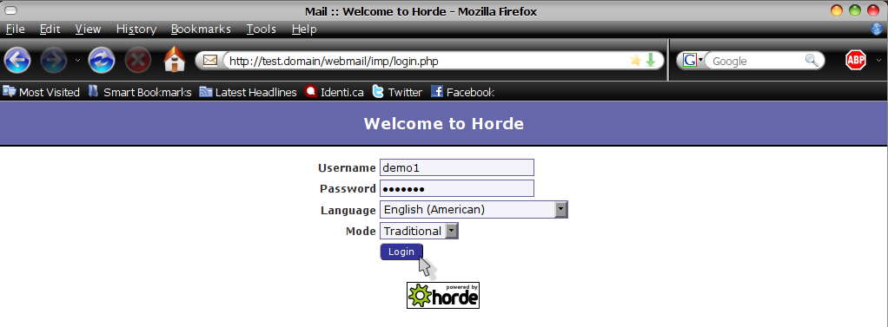
Figure 1
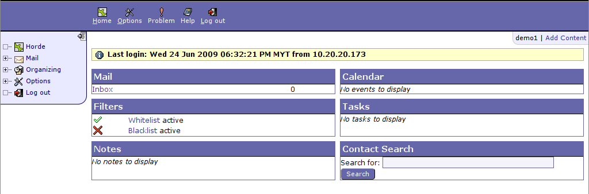
Figure 2
Add Content

The first page will be displayed with default layout as as shown in Figure 2. To customize your own layout, click 'Add Content' at the top of Layout page. The page will appear as shown in Figure 3.
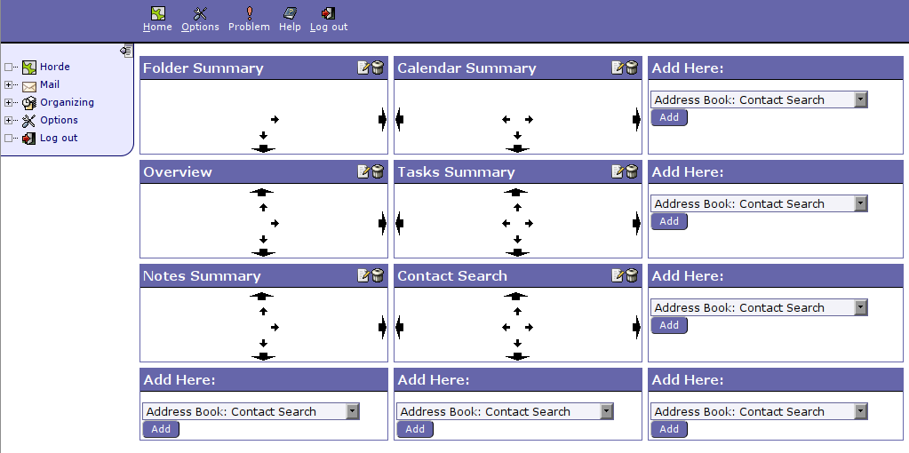
Figure 3

User can can create their own layout using the template/options provided for them. User can choose to change their layout using the dropdown menu and modify options in the layout template, for example as shown in figure 4.
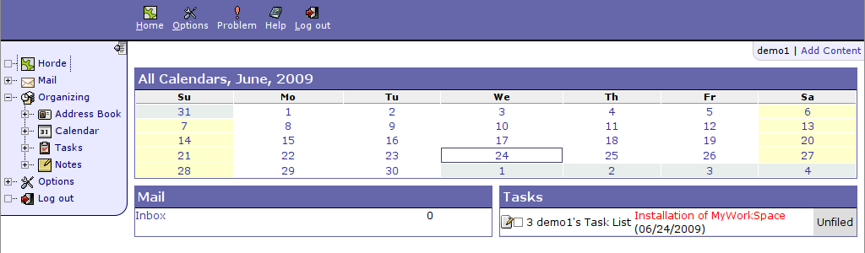
Figure 4

Setting Up Options
In the 'Options', you can personalize your e-mail account. There's some options available such as 'Personal Information' and 'Display Options'. Click 'Options' in the left menu selection or you can click on the icon , by default it will show the 'Global Options', See Figure 5.

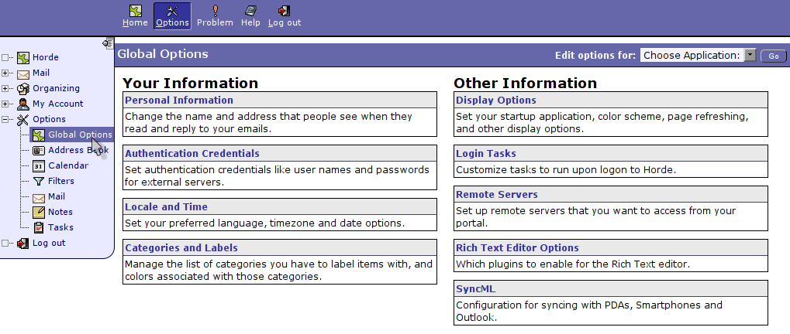
Figure 5

You can change the settings in the 'Options' by clicking on the Options subject such as 'Display Options' or 'Categories and Labels'. Next it will show you setting of the Options you desire to change. Now you can personalize it to your liking.

Change Color Scheme
For example, we will show how to change color scheme for your webmail

Options → Global Options → Display Options
(It will show panel options as shown in Figure 6)
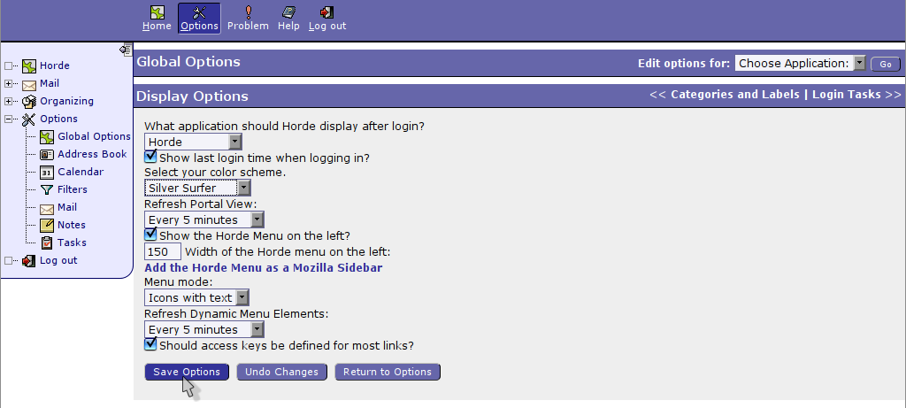
Figure 6
As for this example, we are changing color scheme from Blue and White to Silver Surfer (as shown in the Figure 6). We can see the difference in Figure 7.

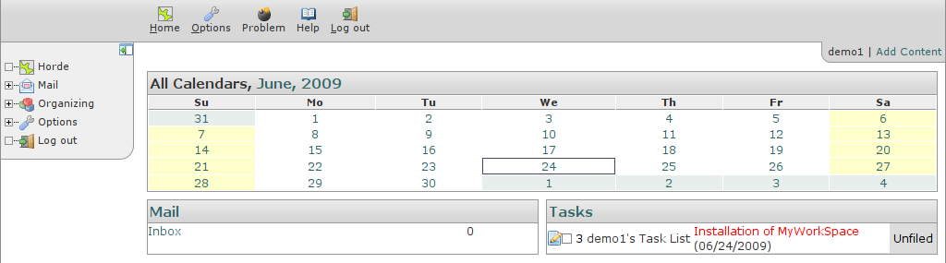
Figure 7

Handling E-mail
Click 'Mail' in the left menu. IMP Webmail will open user inbox.
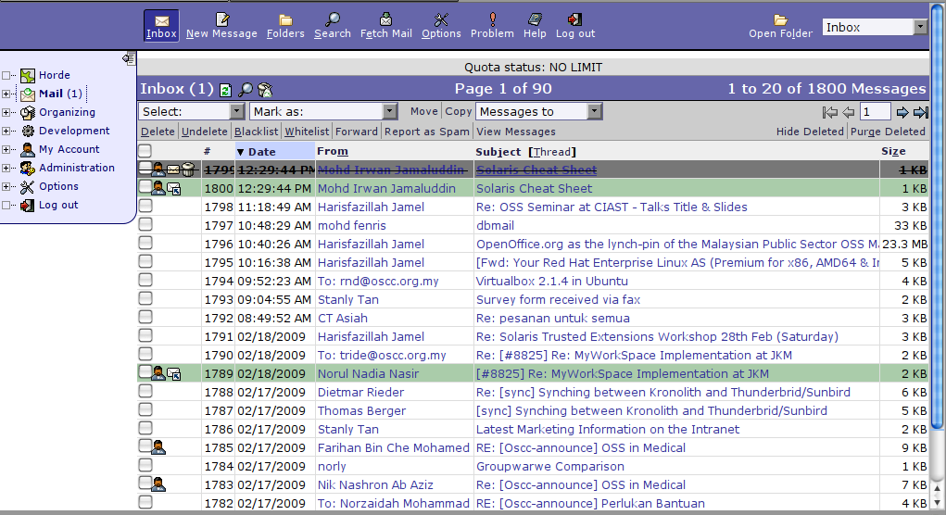
Figure 8

How to Manage Messages
There are many functions provided for the messages, such as delete, undelete, categoried the message as blacklist or whitelist, forward, report the messages as spam or innocent and also view the message. The menu link for this functions are available at the top and bottom of the inbox. This link will be functioned if at least one message is selected in the checkbox.

Sorting Messages in the Folder
The messsages can be sort by date, senders, size, subject and thread. Click the heading ('Date', 'Subject', 'From') by which user wish to sort. The heading will change color to indicate the current sort order. User can reverse the sorting direction using the triangle icons ( and ) next to the heading (for example, to show newest messages first instead of oldest, when sorting by date).
A string of successive replies to the same original message forms what is called a thread. It is often useful to view messages via such a threaded view, so that user can read (or skip) all the messages of each subject in sequence. This is especially useful if user want to reply to a message, as threading lets user easily check if someone else has already replied with the same information.

Message Flags
Message at the left side of the screen provide information about each message. In addition, messages are colour coded to indicate their status. There is a color legend at the bottom of the message list to help identifying the meaning of the colours.
Flag | Colour | Meaning
 | blue | Unread Message
(no flag) | white | Seen message: Message you have opened at least once.
 | green | Answered message: Message you have replied to.
 | pink | Important Message: One that you have flagged as important and in high priority.
 | dark gray | Deleted Message: Message that you mark as deleted.
 |  | Draft Message: Message that you want to send later.
 |  | Personal: The message was addressed to you individually.
 |  | Attachments: The message contains attachment.

Checking for New E-mail
There are multiple ways to check for new (incoming) mail.
1) Click 'Refresh' button (located at upper left of the message).
2) Refresh web browser
3) Configure the applications options to automatically check for new mail on a
regular basis. (in Mail Options -> New Mail)

Reading Messages
To read a message, click the 'sender' or 'subject' link of the message, then the message window will appear.
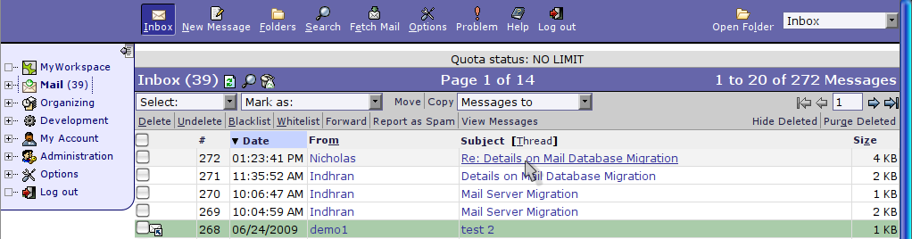
Figure 9

The email attachments will also appear at the parts of the E-mail header. Normally there would be hyperlink at the filename (except for binary attachment with no suitable application to open), so users can directly click the filename or click 'Download' to get the attachment. In case an E-mail have multiple attachment files, another way is to click 'Download All Attachment (in .zip file)' to get all attachments in zip file.

Some explaination on the link provided when user open the message.
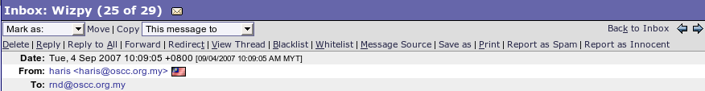

mark for
delete
reply,
forward or
redirect
message
accept
(whitelist) or
reject
(blacklist)
this sender
return to
Inbox
view actual
(raw) text of
message
print this
message
go to next or
previous
message

Figure 10

Sending and Composing Messages
Click 'New Message' in the top menu and a 'Message Composition' window will appear.
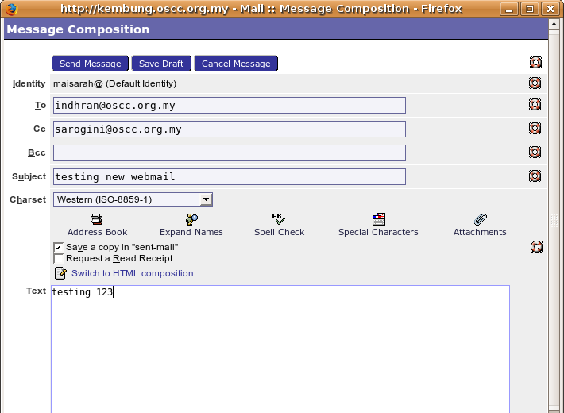

Figure 11

At the top of the message composition window are the 'header' fields. This is where receiver,subject of message and what character set of email will be encoded in. If sending to multiple people, separate the addresses with commas (not semi-colons or spaces – these will not work properly)
User can use 'Address Book' function to add email address into the appropriate 'To', 'cc' or 'Bcc' fields. After finished, click button 'Send Message' to send the message.

Saving Drafts messages and Outgoing Messages
Users can click 'Save Draft' if they are not going to send their composed message. The draft message will be saved under 'draft' folder.

Replying and forwarding Messages
Open a message that user wish to reply and click 'Reply' (to the sender only) or 'Reply To All' (to the sender and all other recipients). A window similar to 'Message Composition' will appear with the recipients and the subject already filled in automatically. Enter text message and click 'Send Message' button to send the reply.
Forwarding message is sending any of messages to another person. In this webmail user can use either 'Forward' of 'Redirect' link at the top of the message.
'Forward' sends the message with user's email address as the 'From' address. A new message window will open with the subject already filled in automatically. The original message text will be in the body of the message, and user can add additional message text. Click 'Send Message' to forward the message.
'Redirect' simply bounces the message to the new person with the original 'From' address intact (it will look like it came from the original sender). Redirect does not allow user to make changes or additions to the message. A new message window will not open, user will simply be prompted for the email address that user wish to redirect to. Press the 'Redirect Message' button to send the message.

Sending Attachments
In the bottom section of 'Attachment' in the 'Message Composition' window, click 'Browse' to select file user wish to attach in the message. The selected file will be shown in the Attachment field.
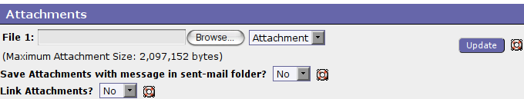
Figure 12

Spell Checking
During the composition of an e-mail, the system will run spell checking based on the language you choose in Login session.

Deleting and Moving Message
To delete a mail message, select the message by clicking the checkbox on the left of the message. Then click the link 'Delete' (either at the top or bottom of the page).
Deleting can be configured in two different modes – delete mode and trash mode.
In delete mode, the messages will be marked for deletion. It will only marked for deletion but not physically deleted until user 'purge' their deleted messages by click the link 'Purge Delete'.
Until purged, the deleted messages will still appear in message listings, and users can still revisit them and in some cases even 'undelete' them. Users can hide the deleted messages by click the link 'Hide Deleted' or click 'Show Deleted' if they want to show it back. (either at the right top or right bottom).
In trash mode, the messages are moved to a trash folder when deleted. Again, they are not actually deleted, only moved to the trash folder, until user empty the trash folder. The messages can be undeleted by moving them out of the trash folder and into another folder, if desired. The trash folder can be empty manually or schedule it automatically at scheduled times.

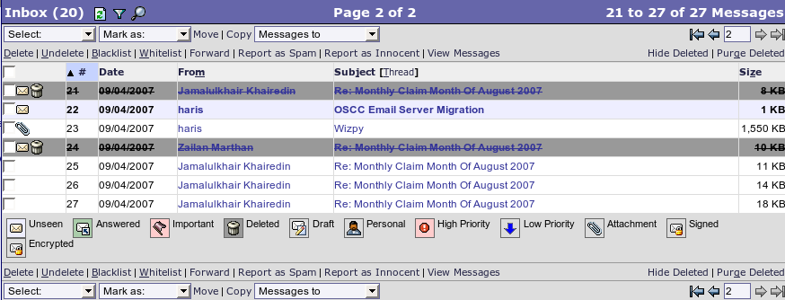
Figure 13

Selecting and Marketing Messages
Users can select the messages in a certain folder from the 'Select' pull-down list. Users can also mark the messages under different categories from the 'Mark as' pull-down list.
For example, users can mark the messages that are important to them by first highlighting a message and then Mark as 'Important'. Later thry may want to select all the important messages that had marked before by using the 'Select' drop-down list. Now, all the messages they had marked as important will show up with a tick mark in front of the messages.
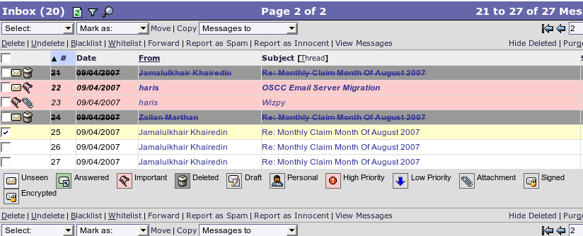
Figure 14

Moving or Copying Messages
Users can move or duplicate a copy of the message to different folders. To do so, select the message that users wish to move or copy by selecting the checkbox at the left of the message. Then click the link 'Move/Copy' (the same links appear both at the top and at the bottom page of the messages) and select the folder that users wish to move or copy the messages to from the 'Messages' to pull-down list.

Managing Mail Folders
Users can manage mail folders by clicking the icon (Folders) from the tool bar at the top menu. After that, 'Folder Navigation' will appear.
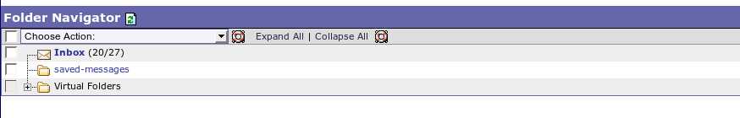

Figure 15
In 'Choose Action' pull-down menu, there are many actions in managing the folders, such as creating and renaming the folder.
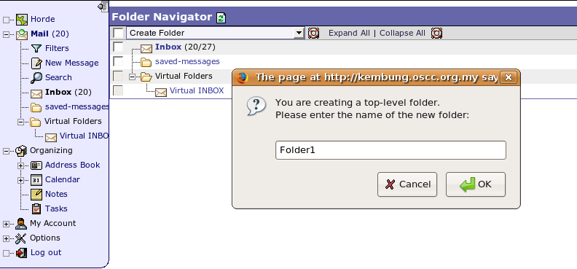

Figure 16
For example, to create a folder, choose 'Create Folder' menu from the pull-down list. A dialogue box will appear, type the name of the folder to be created.
Then, click 'OK' button and the new folder wil appear in the 'Folder Navigation' window and it will also listed in 'Open Folder' pull-down list.
Users can rename or delete the mail folders by clicking the appropriate options under the 'Choose Action' pull-down list. All the messages inside the folder will be deleted if users delete a folder.

Auto-Reply (Vacation)
Vacation is a module for managing user e-mail "vacation notices" or "auto-responders." It works via a local vacation program which must be installed and functioning on the server. It supports vacation programs using the .forward-style forwarding mechanism supported by several popular mailers.
To enable this function, go to 'Filters' and click the red link 'disable-click to enable' under Vacation.

Auto-forrward
Forwards is a module for setting user e-mail forwards with support for several popular mailers.
If users want to auto-forward their email to another mail account, go to 'Filters' and click the 'Forward'. Enable 'Keep a copy of messages of this account?' and put email addresses in the text area given.

Address Book
Address book can help to store email addresses and personal contact details to provide handy reference.

Features:
- Distribution lists/email groups, also across address books
- Simple and advanced search forms
- Customizable address book listings
- vCard support
- Address book pager (rolodex)
- Customizable contact fields
- Integration of existing address books

Setting Up Address Book
To manage address book, click 'Organizing' -> 'Address Book' in the left menu

- Add an address
Users have to choose which address book they want to add-in. The mandatory field is Name and also the email. After finish entering the data, click 'Add' button.
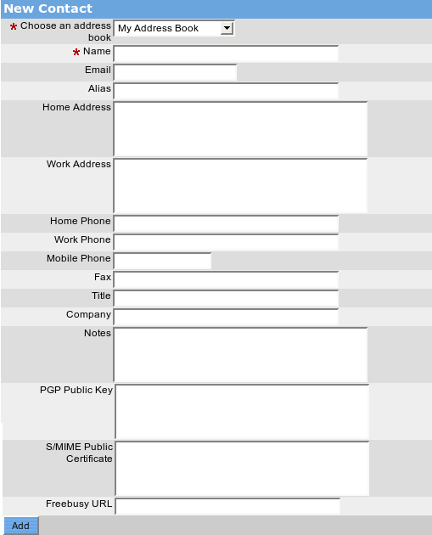

Figure 17

- Search an address
The 'Search' function allow search by 'Name' and 'Email'. For more fields for searching, click 'Advance Search'. Input the keyword and click button 'Search' to start searching.
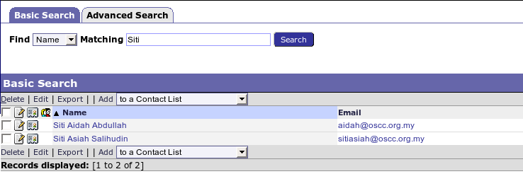
Figure 18
- Browse the address book
Click the icon 'Browse' to browse the contents of your address book.
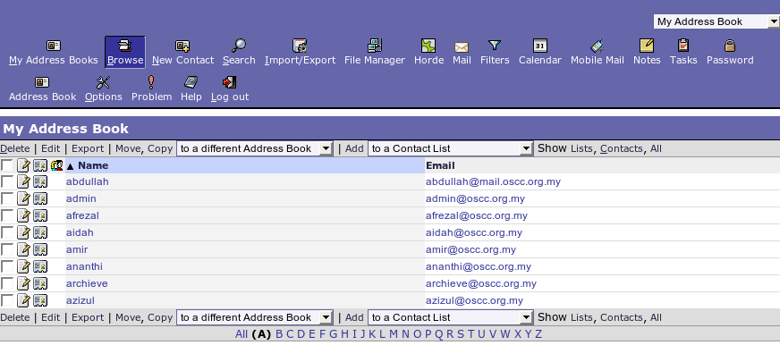
Figure 19

- Import/export an address book
Click the icon (Import/Export) to import an address book into your address book or to export your address book to your own disk.

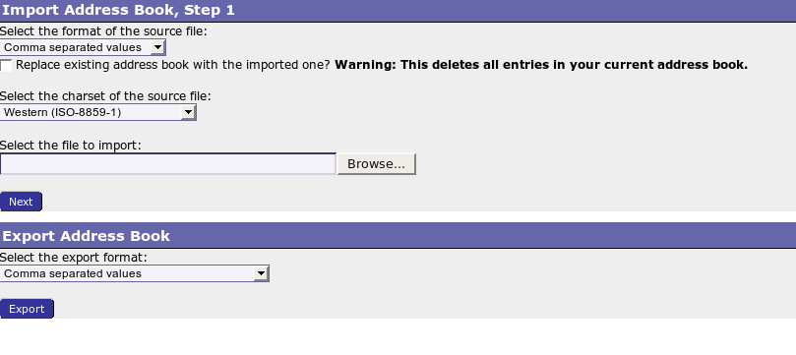
Figure 20

Calendar
MyWorkSpace provides a stable and featureful individual calendar system for every user, with integrated collaboration/scheduling features. It allow repeating events, all-day events, custom fields, keywords, shared calendars, generation of free/busy information and managing multiple users through 'Horde Authentication'.

Features:
- Day, week, work week, month and year views
- Recurring and all-day events
- Alarms with email notifications
- Simple and advanced search forms
- Meeting planning, also with other calendar applications
- Email notification about changed events
- Remote calendar subscriptions
- External client integration (Outlook, Apple iCal, Mozilla Sunbird)
- iCalendar and iTip support

Click the 'Calendar' icon in the left menu of web-page to view user individual calendar. Calendar can be viewed either by day, week, work week, month and year.

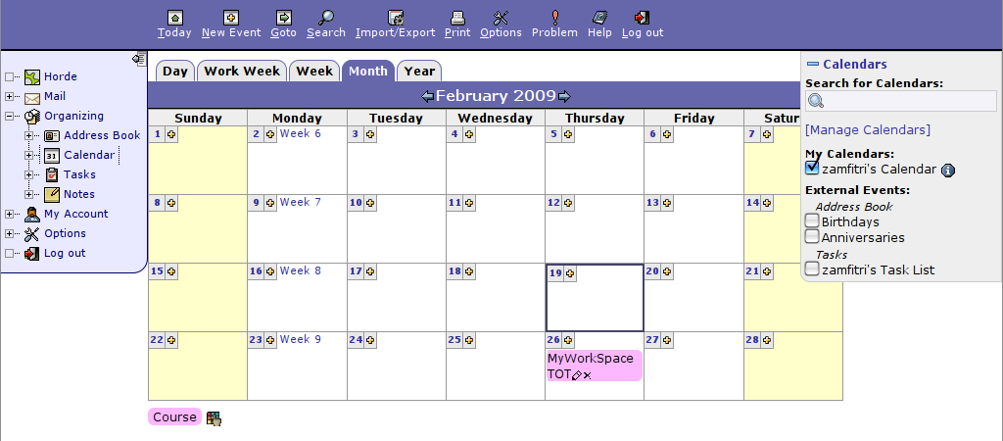
Figure 21

Create and Share Calendar
Click 'Manage Calendars' at the right menu for Calendar to create and gave permission for sharing purpose.
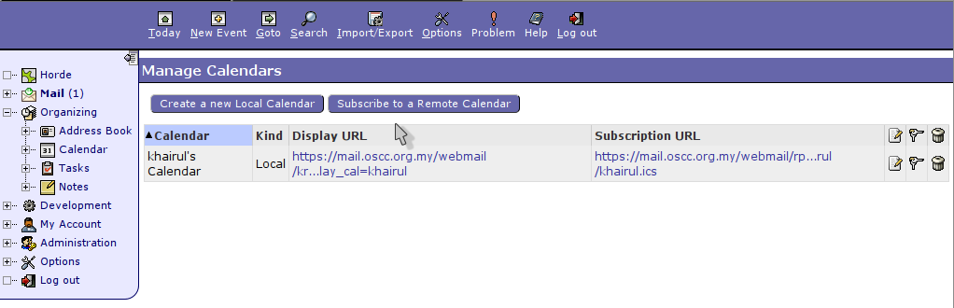
Figure 22
Go to 'Create a New Local Calendar' to create a new calendar. Go to icon to make a sharing calendar.
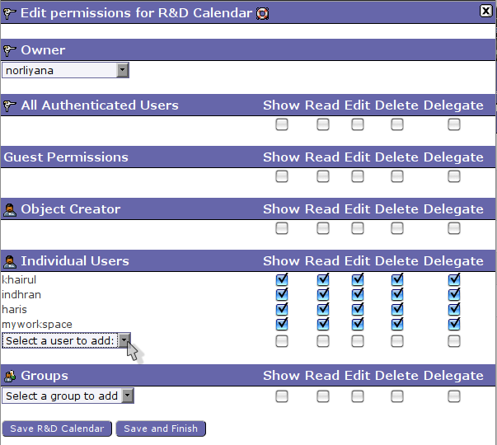
Figure 23

User can choose to either share their calendar with Individual Users or by Groups.

To add an event
Click 'New Event' and user have to enter the information about the event.
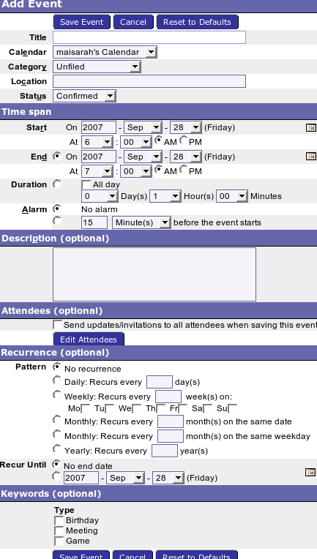

Figure 24
Some information is needed for some functions in calendaring. User can on the alarm system for the event and specify when it suppose to be on. Alarm can be recurrence daily, weekly, monthly or yearly and it will be repeated until users set the end date of the recurrence.
An event also can be shared to another users who are involve in the event and an email notifications will be sent to the attendees.

Notes
Notes and memo in MyWorkSpace lets users keep free-text notes and other bits information which doesn't fit as contact, a todo item or an event. We also can share our notepads with others by giving other user permission to access to the notepad.

Features:
- Fulltext search
- Character counter

To view Notes
Click on Notes on the left menu, under 'Organizing'. It will displayed list of your notepad as default. See Figure 24.
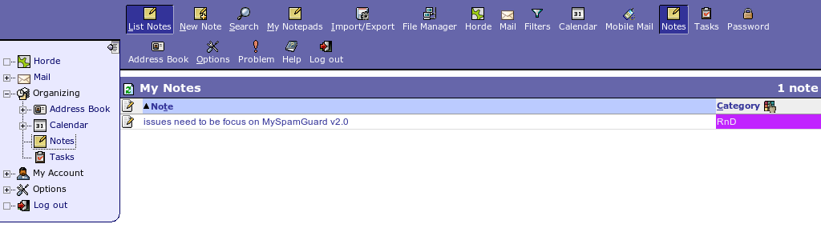
Figure 25

Add New Note
Click 'New Note' at the top of the menu and user can insert all the notes here. This field provide text counter.
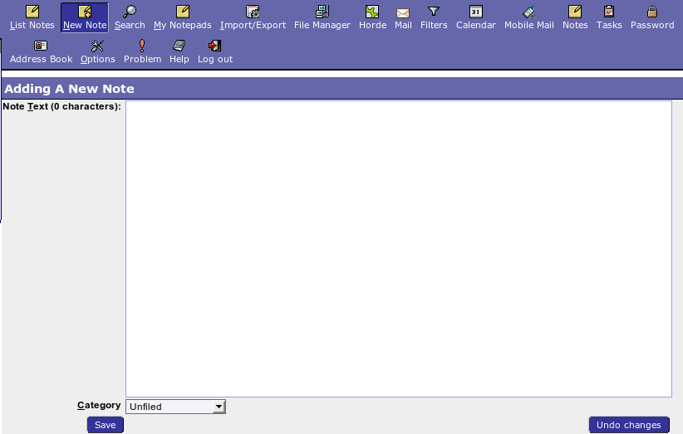

Figure 26

Search Note
Click on 'Search' at the top of the page. Search 'Note' functioned by keywords entering and its scope are first line or full text.

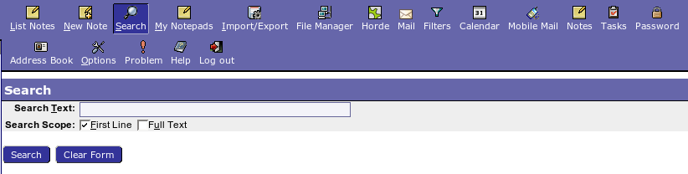
Figure 27

Creating and Sharing Notepad
Users can create and give them permission to other user. Perform this function by click on 'Manage Notepads' at the top of the page. The steps are just same like creating and sharing calendar.

Task List
Nag stores todo items.
Features:
- Priorities and due dates
- Searchable descriptions
- Email notification about changed tasks
- Integration into external clients like Apple iCal, Mozilla Sunbird, Microsoft Outlook
- vTodo support

Click Task button in the left menu and you will see the list of task (all tasks, completed tasks, and also incompleted tasks).

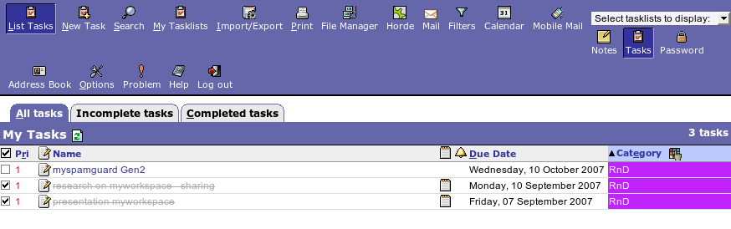
Figure 28
To add new task, click (New Task). Users need to state the task name and the dateline. After finish, click 'Save' button.
Other functions such as creating and sharing, import/export and search are also provided for tasklist. The step is just the same as Calendar and Note.

Change Password
To change your password, go to 'My Account' and click on 'Password' menu on your left. This window will appear. Set up your new password here and click 'Change Password' button after reset your new password.

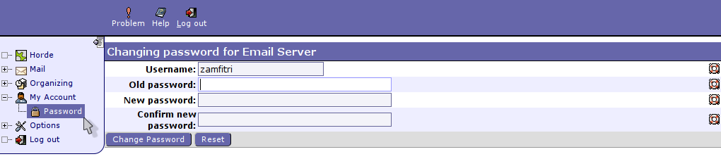
Figure 29

